Coulbourn wiring

Feeders:

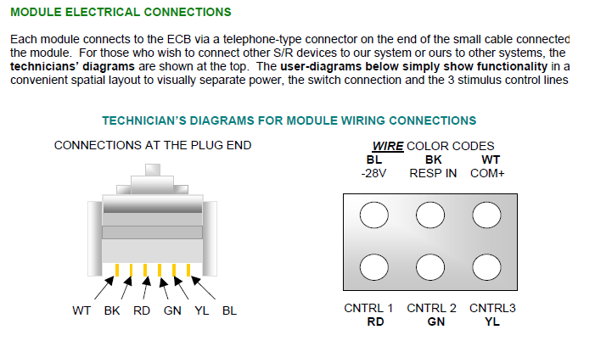
The plug end shown is on the pellet dispenser, so the interface box needs to have the jack wired correspondingly. Pellet dispenser port pinout is:
WT: common ground
BL: -28V (always on when interface box is on)
RD: -28V or 0V, switchable under TTL control (to dispense a pellet)

Actual mappings:

WT – Orange
BL – Blue
RD – Green

Photobeams:

Coulbourn photobeam units also have a RJ-11 plug, as above, but uses a different set of channels compared to a pellet dispenser:
WT: common ground
BL: -28V (always on when interface box is on, for photobeam)
BK: photobeam report (to TTL input on Neuralynx), note that this is -28V when beam is broken!

Using Cat5e cable in running room 1, this is mapped as

WT – Orange
BL – Blue
BK – Brown

