***Motivational-T Task, R050***

***Overview*** We attempt to manipulate the subject’s motivational state by controlling access to food or water prior to each experimental session. The main task requires that a rat navigate a simple T-maze unidirectionally, making a decision at the choice point for food (left) or water (right). The rat then sits for a period on one of two pedestals before the start of the next trial. All procedures were in accordance with the Canadian Council for Animal Care policy on the treatment of experimental animals, and approved by University of Waterloo Animal Care Committee, protocol #11-06.

***Subject***Male Long-Evans rat, R050 (born Aug 7, 2013) was 7 months of age at the time of implantation (March 17, 2014). Missing middle digit on left forepaw, likely not congenital. Rats were pre-handled before training in order to familiarize them with the researcher. When training began, rats were placed on alternating food (deprived to no less than 90% body weight) and water restriction (access for at least 8 hours per day) to encourage performance on the tasks.

***Microdrive array:*** 16 tetrodes targeting dorsal hippocampus (CA1), 4 references (two in corpus callosum, two below CA1). Verified through histology.

***Behavioural Task*** Rats were placed on food and water restriction that alternated daily. They were trained on a T-maze to make a left or right turn at the choice point for food or water, respectively (they were given a small amount of water and two test pellets before the task to “remind” them of the reward options). A barrier was used to prevent movement in the reverse direction. Upon reaching the reward site at the ends of the maze arms, rats consumed their reward and climbed onto a movable pedestal where they remained until the beginning of the next trial. Each intertrial period began at a length of two minutes, and decreased with each trial to as short as one minute or less (Figure 1). The purpose of the intertrial period is to provide enough time for multiple SWR events to occur. A barrier was placed at the choice point during some trials in order to force the rat down the unfavoured arm a minimum of five times per session, thus establishing the place field locations for that day. Sometimes a rat would try to reverse directions, running back towards the starting position. The experimenter prevented large traversals in the counter direction using a handheld barrier that was moved forward to encourage movement in the proper direction. Trials in which this occurred are called “bad trials”, and can be found the rat’s ExpKeys (the list of standard blocked trials can also be found here).

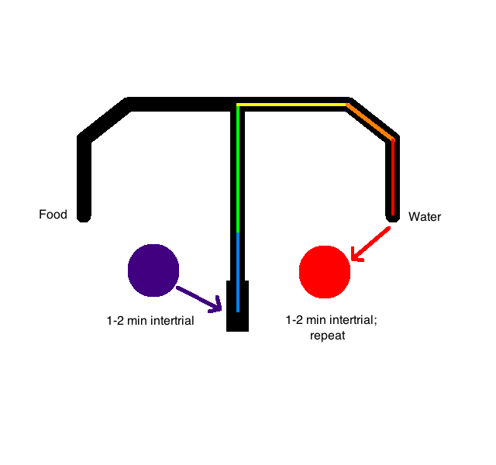

**Figure 1:** The T-maze task lasts for 40 minutes. Approximately 15-20 trials occur, during which the rat waits 1-2 minutes on a pedestal (purple, red) before being transferred to the track where he can choose to make a left turn (food) or right turn (water). When he reaches the end of a reward arm, he is transferred to the corresponding pedestal for another intertrial interval of 1-2 minutes.

***Recording*** Two cables with headstages are plugged into the microdrive arrays on the subjects’ heads. Neuralynx records local field potentials across the references and tetrodes. Simultaneously, a video-tracking algorithm keeps track of the animal’s 2D position based on headstage LEDs picked up by an overhead camera. A typical session consists of a prerecord, the main task, and a postrecord (Table). Pre- and postrecords are conducted while the rat is sitting on one of two T-maze associated pedestals. The starting pedestal sequence across days is determined before the experiment starts, and is generated randomly.

Recording is stopped and started between each major recording epoch (Table below), and is evident when plotting the CSCs.

**Table**

|  |  |  |  |
| --- | --- | --- | --- |
|  | **Prerecord** | **Main task (‘Recording’)** | **Postrecord** |
| Rat 3 (R050) | 25 | 40 | 15 |

**Blocked Trial:**

